**Mandatory Disclosure**

|  |  |  |
| --- | --- | --- |
| 1 | Mandatory Disclosure updated on | 18th April 2017 |
| AICTE permanent ID. | 1-441996501 |
| Date and Period of last approval | April 2017 (2017-2018) |
| 2 | Name of the Institution | Pimpri Chinchwad Polytechnic |
| Address of the Institution | Sec. No. 26, Pradhikaran, Near Akurdi Rly. Station Nigdi, |
| City and Pin Code | Pune 44 |
| State /UT | Maharashtra |
| Phone number with STD code | 020-27654156 |
| FAX number with STD code | 020-27658797 |
| Office hours at the Institution | 10 A.M. to 6 P.M. |
| Email : | [principal@pcpolytechnic.com](mailto:principal@pcpolytechnic.com) |
| Website | [www.pcpolytechnic.com](http://www.pcpolytechnic.com) |
| Nearest Railway Station (dist in Km) | Akurdi Station, 0.5 Km |
| Nearest Airport (dist in Km) | Lohagaon Air port, 25 Km |
| 3 | Type of Institution | Private-Self Financed |
| Category (1) of the institution | Non Minority |
| Category (2) of the institution | Co-Ed |
| 4 | Name of the organization running the Institution | Pimpri Chinchwad Education Trust |
| Address of the Organization | Sec. No. 26, Pradhikaran, Near Akurdi Rly. Station, Nigdi, Pune-44 |
| Registration No. | E-1379 |
| Registration date | 18/09/1990 |
| 5 | Name of the affiliating University | Maharashtra State Board of Technical Education (M.S.B.T.E) |
| Address | 49, Kherwadi, Bandra (E), Mumbai 400 051. |
| Latest affiliation period | 2017-2018 |
| 6 | Name of Principal / Director | Prof. Vidya S. Byakod |
| Exact Designation | Principal |
| Phone number with STD code | 020-27654156 |
| FAX number with STD code | 020-27658797 |
| Email | vidyabyakod@rediffmail.com |
| Highest Degree | M.E. |
| Field of Specialization | Structure |

**7. Governing Board Members List:**

|  |  |
| --- | --- |
| **Name of Member** | **Designation** |
| Shri. D.P.Landge | Chairman , PCET |
| Smt. Padmatai Bhosale | Vice Chairman |
| Shri.V.S. Kalbhor | Secretary , PCET |
| Shri. S.D. Garade | Treasurer , PCET |
| Shri. Bhaijjan Kazi | Trustee(Member) |
| Shri Harshawardhan Patil | Trustee(Member) |
| Dr. Girish Desai | Executive Director and Academician |
| DTE Nominee | Member Jt. Director Regional Office |
| MSBTE Nominee | Member Dy. Secretary Regional Office |
| AICTE Nominee | Member |
| Shri .P.D.Vispute | Member |
| Smt.Vidya Byakod Principal | Member Secretary |
| Mr. Wadhokar Shrikant | Member and Industrialist |
| Shri.B.V.Mane –  Vice Principal and Faculty representative | Member |
| Shri.P.L.Deotale –  HOD Faculty representative | Member |
| Shri.A.V.Raipure –  HOD Faculty representative | Member |
| Frequency of Governing Body Meeting and Date of last Meeting | Once in a Year Last meeting 10th April 2017 |

**9. Organizational Chart:**



**10. Grievance redressal mechanism for faculty, staff and students:**

***Anti Ragging Committee:***

Committee is formed by the Principal and meeting is also arranged time to time. Banners are displayed in the campus regarding anti ragging and the names of committee members with their contact nos. and mail address.

|  |  |  |  |
| --- | --- | --- | --- |
| **Sr. No.** | **Name of Staff** | **Designation** | **Department** |
| 01 | Mr. B.V. Mane | Vice Principal | Science & Humanities |
| 02 | Mrs. S.L. Mortale | I/C HOD | Information Technology |
| 03 | Mr. S.R. Patil | Foreman | Workshop |

***Activities undertaken :***

* Formation of committees by the Principal .
* Planning of meetings at the beginning of the semester
* Display of ragging prohibition notices on all departments notice boards
* Regular meetings are taken to resolve the problems

***Women Grievance Redressal committee /Internal Complaints committee:*** The WGRC is formed in order to keep healthy working atmosphere among the faculty . This cell helps women faculty and students to record their complaint and solve their problems related to resources and personal grievance . The Women’s welfare committee maintains a file which is kept with members of the committee. As soon as a complaint is registered the committee meets and decides on the course of action and implementation to solve the issue.

|  |  |  |
| --- | --- | --- |
| **Sr. No** | **Name of the Staff** | **Designation** |
| 01 | **Prof .V.S. Byakod** | **Chairman** |
| 02 | Mrs. V.S. Kharote Chavan | Member |
| 03 | Mrs. S.S. Jogdand | Member |
| 04 | Student representative | Student (2) |

***SC/ST (Prevention of Atrocities )Committee:***

List of members :

|  |  |  |
| --- | --- | --- |
| **Sr. No** | **Name of the Staff** | **Designation** |
| 01 | Prof. V.S. Byakod | Chairman |
| 02 | Mrs. D.P Thete | Member |
| 03 | Mr. A.A. Marathe | Member |

This cell is formed to ensure fair treatment to reserved category staff and students . Institutes overall ambience is extremely fair for all stake holders including students from economically weaker sections . Administration helps the students to fill the scholarship forms and complete other documentation to entitle their learning at concessional fees. Students are properly informed about different scholarship schemes , deadlines to avail the benefits .

**11. Courses Offered:**

|  |  |  |
| --- | --- | --- |
| **Sr. No.** | **Course** | **Intake** |
| 1. | Civil Engineering | 60 |
| 2. | Automobile Engineering | 60 |
| 3. | Computer Engineering | 60 |
| 4. | Electronics & Tele-Communication Engineering | 60 |
| 5. | Information Technology | 60 |
| 6. | Mechanical Engineering | 120 |
| 7. | Mechanical Engineering  (Second Shift) | 120 |
| 8. | Computer Engineering  (Second Shift) | 60 |

**12. Distinguished Alumni:**

|  |  |  |
| --- | --- | --- |
| **Sr. No.** | **Name** | **Organization** |
| 1 | Mr. Parag P. Kulkarni | Bajaj Finance Ltd. |
| 2 | Mr. Balkrishna Kelkar | Pavilion Data |
| 3 | Mr. Ashish Dattatray Shelar | IBM India Pvt. Ltd. |
| 4 | Mr. Rajesh Solanki | Aquilaminds Softwares Pvt. Ltd. |
| 5 | Mr. Chetan P Pise | HCL |
| 6 | Ms. Poonam B. Thorat | P. K. Technical Campus, chakan, Pune. |
| 7 | Mr. Londhe Swapnil Gulab | Krawler Information Systems |
| 8 | Mr. Mahesh Shankar Zendge | Infosys Limited |
| 9 | Mr. Pushkar P. Phule | Infosys Limited |
| 10 | Mr. Vishal Baban Tambe | SAP Labs |
| 11 | Ms Shweta Mandavgane | John Deere India Private Limited, Pune |
| 12 | Mr Mitesh Gosavi | Accenture, India |
| 13 | Ms Nilima Phatak | TCS Powai |
| 14 | Mr Rahul Vishnu Potghan | Persistent Systems Ltd |
| 15 | Mr SushilKumar Laxman Rajiwade | Clover Infotech , Mumbai |
| 16 | Mr Swapnil Chavan | Outworx/alchemy Solution Pvt. Ltd |
| 17 | Ms Prajakta Govind Kale | TIBCO Software Limited |
| 18 | Ms Mrunalini Malkar | KPIT Technologies, Hinjewadi. |
| 19 | Mr Moulavi Shadaab | Tech Mahindra, Pune |
| 20 | Mr Somnath Dhavale | IBM |
| 21 | Mr Suhas Sayaji Walase | Renishaw |
| 22 | Mr. Jagjit Singh Tank | Thermax R&D division |
| 23 | Mr. Abhay Phatangare | Simply Barbeque and Seaosns Banquet |
| 24 | Mr. HardeepsinghSukhdevsinghMatharu | Wipro Ltd |
| 25 | Mr. Girish Lande | Agiliad technologies Pvt Ltd. |
| 26 | Mr. Mahesh Moreshwar Deo | East Engineers Trainers and Consultants |
| 27 | Mr. Arvind Tapse | Moschip Semiconductor Technology Ltd, |
| 28 | Mr. Avesh Godase | HCL Technologies |
| 29 | Mr. Tushar Bobade | Infosys India Pvt. Ltd |
| 30 | Mr. Vivek Chordia | In2things Automation Pvt. Ltd |
| 31 | Mr. Ajay Jidagi | A Square Electro-Engg. Pvt. Ltd |
| 32 | Mr. Abhijit Undre | Mimic Infotech Pvt. Ltd. |
| 33 | Mr. Abajee Pawar | Tetra Pak, India |
| 34 | Ms. Komal Sable | L & T Infotech |
| 35 | Mr. Rachna Ghadge | L & T Infotech |
| 36 | Mr. Sneha Kumbhar | Magneto IT Solutions Pvt .Ltd |

**13. Teaching Staff**

|  |  |  |  |
| --- | --- | --- | --- |
| **Sr. No.** | **Name of the Staff** | **Designation** | **Qualification** |
| 1 | Prof. Mrs. V.S. Byakod | Principal | M.E. Structures  Ist Class |
| 2 | Shri. S.P. Chaphalkar | HOD | M.E.Mech.(Heat Power)  Ist Class with Distn. |
| 3 | Shri. S.D. Gandhi | Sr. Lecturer | B.E.(Automobile)  Ist Class |
| 4 | Ms. K.M. Dalvi | Lecturer | B.E.(Mechanical)  Ist Class with Distn. |
| 5 | Shri. A.M. Kamble | Lecturer | B.E.(Mechancial)  Ist Class |
| 6 | Shri. A.C. Khan | Lecturer | B.E.(Automobile)  Ist Class |
| 7 | Shri. P.L. Deotale | HOD | M.E. (Mechanical)(Heat Power)  Ist Class with Distn. |
| 8 | Shri. M.P. Chavan | I/C HOD W/S. | B.E. (Mechancial)  Ist Class |
| 9 | Mrs. T.M. John | Sr. Lecturer | B.Tech.(Chemical Engg.)  Ist Class |
| 10 | Shri. A.B. Kulkarni | Sr. Lecturer | B.E.(Chemical Engg.)  Ist Class |
| 11 | Shri. Y.D. Kale | Lecturer | B.E. (Mechancial)  Ist Class |
| 12 | Shri. G.L. Chaudhari | Lecturer | B.E. (Mechanical)  Ist Class |
| 13 | Ms. N.U. Patil | Lecturer | B.E. (Mechanical), M.B.A.  Ist Class, M.E. persuing |
| 14 | Shri. A.A. Mane | Lecturer | B.E. (Mech. Engg.)  Ist Class with Distn. |
| 15 | Shri. V.B. Hiwase | Lecturer | B.E. (Mech. Engg.)  Ist Class |
| 16 | Shri. S.T. Birhade | Lecturer | B.E. (Mechancial)  Ist Class |
| 17 | Ms. M.K. Jadhav | Lecturer | B.E. (Mechanical)  Ist class M.E. persuing |
| 18 | Ms. R.P. Khobragade | Lecturer | B.E. (Mechancial)  Ist Class M.Tech persuing |
| 19 | Shri. M.N. Kudale | Lecturer | B.E. (Mechanical)  Ist Class with Distn. |
| 20 | Ms. A.R. Relekar | Lecturer | B.E. (Mechanical)  Ist Class |
| 21 | Shri. N.M. Kalpund | Lecturer | B.E. (Mechanical)  Ist class |
| 22 | Ms. J.M. Sadgir | Lecturer | B.E. (Mechanical)  Ist class |
| 23 | Shri. V.B. Tharker | Lecturer | B.E. (Mechanical)  Ist Class with Distn. |
| 24 | Shri. C.V. Chimote | Lecturer | B.E. (Mechanical)  Ist class |
| 25 | Shri. H.S. Daund | Lecturer | B.E. (Mechanical)  Ist class |
| 26 | Shri. P.M. Khirapate | Lecturer | B.E. (Mechanical)  Ist class |
| 27 | Ms. M.R. Zade | Lecturer | B.E. (Mechanical)  Ist class |
| 28 | Shri. S.S. Dhanure | Lecturer | B.E. (Mechanical)  Ist class |
| 29 | Shri. B.A. Pawal | Lecturer | B.Tech. (Mechanical)  Ist Class with Distn. |
| 30 | Shri. N.H. Bargaje | Lecturer | B.E. (Mechanical)  Ist class |
| 31 | Shri. T.V. Inde | Lecturer | B.E. (Mechanical)  Ist class |
| 32 | Ms. P.R. Ambekar | Lecturer | B.E. (Mechanical)  Ist class |
| 33 | Shri. K.S. Patil | Lecturer | B.E. (Mechanical)  Ist class |
| 34 | Ms. P.S. Katkar | Lecturer | B.E. (Mechanical)  Ist class |
| 35 | Shri. P.E. Gaidhani | Lecturer | B.Tech. (Mechanical)  Ist Class |
| 36 | Mrs. A.A. Avasthi | HOD | M.E. Civil (Structual Engg.)  Ist Class |
| 37 | Shri. P. P. Jadhav | Sr. Lecturer | M.Tech. (Const. Management) Ist Class |
| 38 | Shri. B.D. Gidde | Sr. Lecturer | B.E. (Civil )  Ist Class with Distn. |
| 39 | Shri. S.N. Nanaware | Lecturer | B.E. (Civil )  Ist Class |
| 40 | Ms. V.N. Kundlikar | Lecturer | B.E. (Civil)  Ist Class, M.E. Persuing |
| 41 | Ms. P.D. Patil | Lecturer | B.E. (Civil)  Ist Class with Distn. M.E. Persuing |
| 42 | Shri. A.V. Raipure | HOD | M.E. Electronics Engg.  Ist Class |
| 43 | Mrs. N.V. Hippalgaonkar | Lecturer | M.E. Electronics (Digital Systems)  Ist Class |
| 44 | Mrs. V.S. Kharote-Chavan | Lecturer | M.E.( Elect.)  Ist Class |
| 45 | Mrs. L.H. Patil | Lecturer | M.E. E & TC (VLSI & Embedded Systems) Ist Class with Distn. |
| 46 | Mrs. A.S. Futane | Lecturer | B.E. (E & TC)  Ist Class |
| 47 | Ms. A.A. Lande | Lecturer | B.E. (E & TC)  Ist Class |
| 48 | Mrs. N.M. Jangale | Lecturer | M.E. (Signal Processing)  Ist Class with Distn. |
| 49 | Mrs. V.R. Deore | Lecturer | M.E. (Digital Electronics)  Ist Class |
| 50 | Mrs. S.V. Naik | Lecturer | M.E. (VLSI and Embedded System)  Ist Class |
| 51 | Ms. P.S. Bhore | Lecturer | B.E. (E & TC)  Ist Class |
| 52 | Mrs. M.S. Malkar | HOD | M.E.( Comp.Engg.)  Ist Class |
| 53 | Mrs. M.A. Parlikar | Lecturer | B.Tech. (Co. Sci.& Tech).  Ist Class |
| 54 | Mrs. G.S. Mujumdar | Lecturer | B.E. Comp.Engg.)  Ist Class |
| 55 | Mrs. B.V. Jadhav | Lecturer | M.E. (Comp.Engg.)  Ist Class with Distn. |
| 56 | Ms. R.R. Patil | Lecturer | B.E. (IT.)  Ist Class |
| 57 | Mrs. P.S. Chavan | Lecturer | M.E. (Comp)  Ist Class with Distn. |
| 58 | Ms. N.S. Meher | Lecturer | B.E. (Comp.Sci. & Engg.)  Ist Class with Distn. |
| 59 | Ms. M.K. Kute | Lecturer | B.E. (Info.Tech  Ist Class |
| 60 | Ms. C.B. Landge | Lecturer | B.E. Comp.Engg.)  Ist Class |
| 61 | Ms. P.M. Maladkar | Lecturer | B.E. (Comp.Sci.)  Ist Class |
| 62 | Ms. A.R. Patil | Lecturer | M.E. (Comp.)  Ist Class |
| 63 | Ms. R. R. Deshmukh | Lecturer | M.E. (Comp. Neytwork)  Ist Class |
| 64 | Mrs. S.L. Mortale | I/C HOD | B.E. Comp.Sci.& Engg. Distn.  M.E. Comp. persuing |
| 65 | Mrs. M.M. Mali | Lecturer | B.E. (Comp.Engg.)  Ist Class |
| 66 | Mrs. S.S. Jogdand | Lecturer | B.E. (Info. Tech.)  Ist Class with Distn. |
| 67 | Ms. T.R. Shinde | Lecturer | B.E. (Comp.)  Ist Class |
| 68 | Ms. N.M. Karolia | Lecturer | B.E. (Info. Tech.)  Ist Class |
| 69 | Shri. M.U. Sanap | Lecturer | M.E. (Comp.)  Ist Class with Distn. |
| 70 | Shri. B.V. Mane | Vice Principal | M.Sc.B.Ed. Appl.Maths.  Ist Class |
| 71 | Mrs. C.C. Patil | Lecturer | M.Sc. B.Ed. Appl. Maths  Ist Class |
| 72 | Ms. K.R. Hagavane | Lecturer | M.Sc. (Maths)  Ist Class |
| 73 | Ms. M.B. Mane | Lecturer | M.Sc. B.Ed. (Maths)  Ist Class with Distn. |
| 74 | Mrs. S.G. Aparnaji | Lecturer | M.Sc. B.Ed. Appl. Maths  Ist Class with Distn. |
| 75 | Mrs. A.S. Shinde | Lecturer | M.Sc. B.Ed. (Maths)  Ist Class |
| 76 | Mrs. A. S. Kale | Sr. Lecturer | M.Sc. (Org.Chemis.)  Ist Class, B.Ed. |
| 77 | Mrs. B.V. Dhopate | Lecturer | M.Sc. (Org.Chemis.)  Ist Class , M.Phil |
| 78 | Shri. A.V. Yadav | Lecturer | M.Sc. (Inorganic Chemistry) Ist Class |
| 79 | Shri. M.S. Pawar | Sr. Lecturer | M.Sc.Appl.Physics with Electronics & DCS) Ist Class |
| 80 | Shri. Y.S. More | Lecturer | M.Sc. (Physics)  Ist Class |
| 81 | Ms. P.D. Dahibhate | Lecturer | M.Sc. (Physics)  Ist Class |
| 82 | Mrs. M.V. Kadam | Sr. Lecturer | M.A. English  Pass Class |
| 83 | Shri. M.S. Wakhare | Lecturer | M.A. English.  Ist Class |
| 84 | Ms. R.P. Jadhav | Lecturer | M.A. English., B.Ed.  Ist Class |
| 85 | Mrs. P.V. Chawardol | Lecturer | M.Sc. (Physics)  Ist Class |
| 86 | Shri. S. M. Ausekar | Lecturer | M.A. B.Ed.(English)  Ist Class |

**List of Non teaching staff**

|  |  |  |
| --- | --- | --- |
| **Sr. No.** | **Name** | **Designation** |
| 1 | Shri. S.R. Patil | Foreman |
| 2 | Shri. K.C. Gavhane | Lab. Asstt. |
| 3 | Shri. R.P. Pawar | Lab. Asstt. |
| 4 | Shri. S.N. Mahajan | Lab. Asstt. |
| 5 | Shri. R.S. Landge | Lab. Asstt. |
| 6 | Shri. J.S. Kadam | Lab. Asstt. |
| 8 | Shri. S.S. Kadere | Lab. Tech. |
| 9 | Mrs. L.D. Nagarkar | Lab. Asstt. |
| 10 | Shri. M.M. Shaikh | Electrician |
| 11 | Shri. A. J. Bhosale | Lab. Asstt. |
| 12 | Shri. R.S. Pawar | Lab. Asstt. |
| 13 | Mrs. M.D. Phadtare-Gade | Lab. Asstt. |
| 14 | Ms. U.K. Kalbhor | Lab. Asstt. |
| 15 | Shri. P.K. Naik | Lab. Asstt. |
| 16 | Mrs. P.V. Gund | Lab. Asstt. |
| 17 | Shri. H.M. Nagale | Instructor |
| 18 | Shri. V.V. Bhalerao | Instructor |
| 19 | Shri.R.B. Gaikwad | Instructor |
| 20 | Shri. S.U. Gaikwad | Instructor |
| 21 | Shri. R.V. Chavan | Instructor |
| 22 | Shri. D.A. Sandbhor | Instructor |
| 23 | Shri. S.V. Kuchekar | Instructor |
| 24 | Mrs. G.T. Jadhav | Lab. Asstt. |
| 25 | Shri. S.D. Jagtap | Lab. Asstt. |
| 26 | Ms. P.S. Gadhave | Lab. Asstt. |
| 27 | Mrs. B.B. Bhase | Office Superintendent |
| 28 | Shri. S.R. Khatale | Head Clerk |
| 29 | Mrs. D. P. Thete | Sr. Clerk |
| 30 | Shri. C.S. Shedge | Store Keeper |
| 31 | Mrs. M.R. Dhamale | Sr. Clerk |
| 32 | Shri. D.P. Khandekar | Typist Clerk |
| 33 | Shri. S.N. Shirude | Jr. Clerk |
| 34 | Shri. R.S. Dhumal | Jr. Clerk |
| 35 | Shri. U.A. Landge | Accountant |
| 36 | Mrs. M.R. Shahane | Account Assistant |
| 37 | Shri. A.A. Marathe | Jr. Clerk |
| 38 | Shri. Y.C. Landge | Clerk |
| 39 | Shri. R.M. Shahane | Librarian |
| 40 | Shri. S.U. Khedekar | Asstt. Librarian |
| 41 | Shri. S.U. Dhoke | Lib. Asstt. |

**Class IV**

|  |  |  |
| --- | --- | --- |
| **Sr. No.** | **Name** | **Designation** |
| 1 | Shri. S.G. Landge | Peon |
| 2 | Shri. S.K. Landge | Peon |
| 3 | Shri. S.M. Kadam | Peon |
| 4 | Shri. D.B. Sorte | Peon |
| 5 | Shri. P.G. Kalbhor | Peon |
| 6 | Shri. G.B. Landge | Peon |
| 7 | Shri. D.S. Pawar | Peon |
| 8 | Shri. M. M. Sakure | Peon |
| 9 | Shri. Y.V. Landge | Peon |
| 10 | Shri. N.K. Kate | Peon |
| 11 | Shri. M.S. Gaikwad | Peon |
| 12 | Shri. N.N. Kalbhor | Peon |
| 13 | Shri. V.W. Kawale | Lab. Attend. |
| 14 | Shri. A.V. Mundhekar | Peon |
| 15 | Shri. R.H. Phuge | Peon |
| 16 | Ms. S. S. Bhalekar | Office Attendant |
| 17 | Shri. S.B. Kalambate | Driver cum Peon |
| 18 | Shri. A.U. Shaikh | Driver cum Peon |
| 19 | Shri. B.B. Bhegade | Driver cum Peon |
| 20 | Shri. S.H. Bhegade | Mali |
| 21 | Shri. D.L. Surwase | Peon |

**14. Admission Quota:**

|  |  |  |  |
| --- | --- | --- | --- |
| Admission criteria | | 80% CAP, 20% Institute Level | |
| Number of Tuition fee waivers offered | | 5% of Sanction Intake | |
| Admission Calendar | | As per D.T.E. Notification | |
| Fee Structure | | | |
| **Particular** | **OPEN** | **OBC** | **SC/ST /SBC/VJNT /TFWS/SC** |
| Tuition Fees | 52727 | 26364 | 0 |
| Development Fee | 5273 | 5273 | 5273 |
| Exam Fee | 1200 | 1200 | 1200 |
| Enrollment Fee | 210 | 210 | 210 |
| National Insurance | 454 | 454 | 454 |
| ISTE Membership | 200 | 200 | 200 |
| **TOTAL AMOUNT** | **60064** | **33701** | **7337** |

**15. Infrastructure Information:**

**Classroom / Tutorial Rooms Facilities**

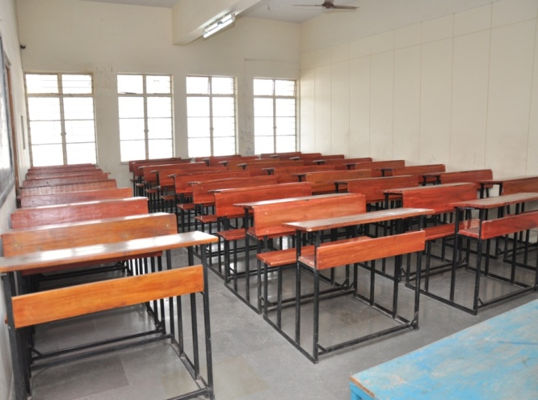 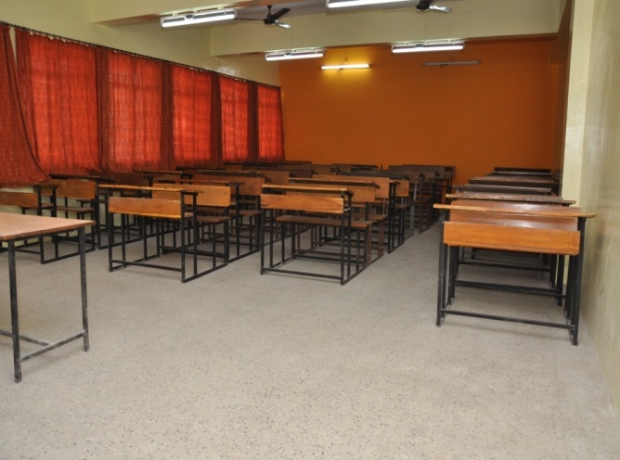

**Laboratory**

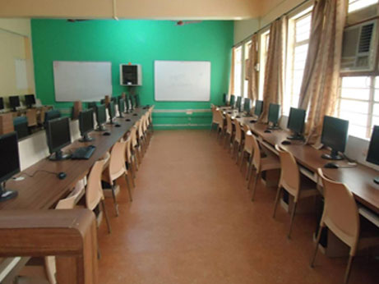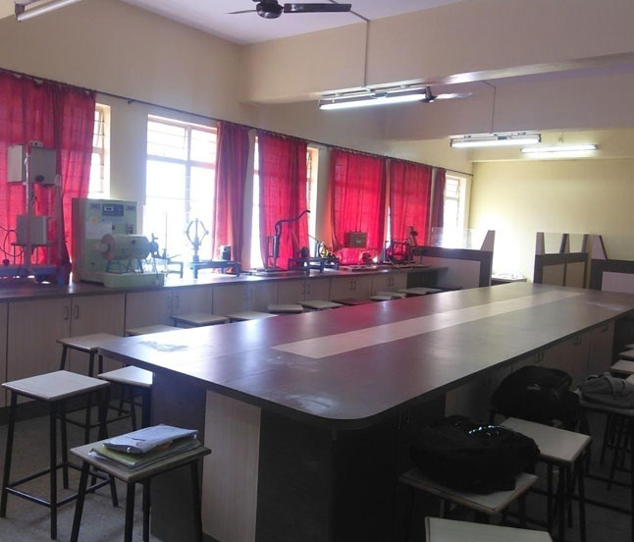

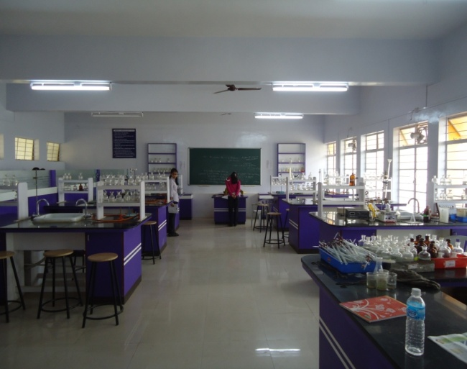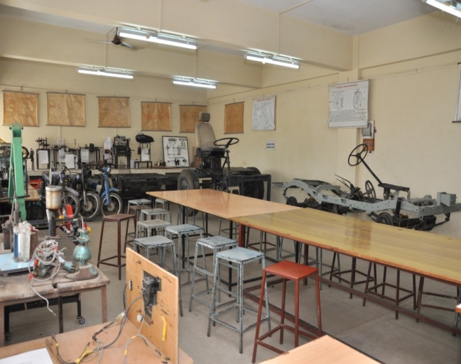

**Computer Centre Facility**

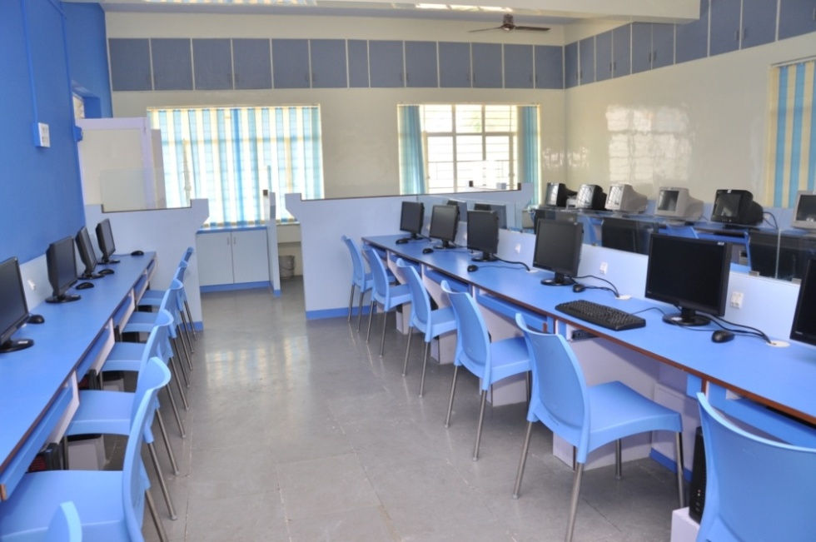

**Library Facilities**

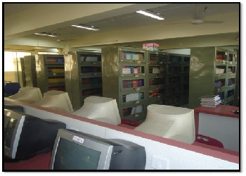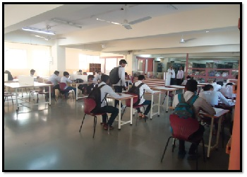

**Seminar Halls**

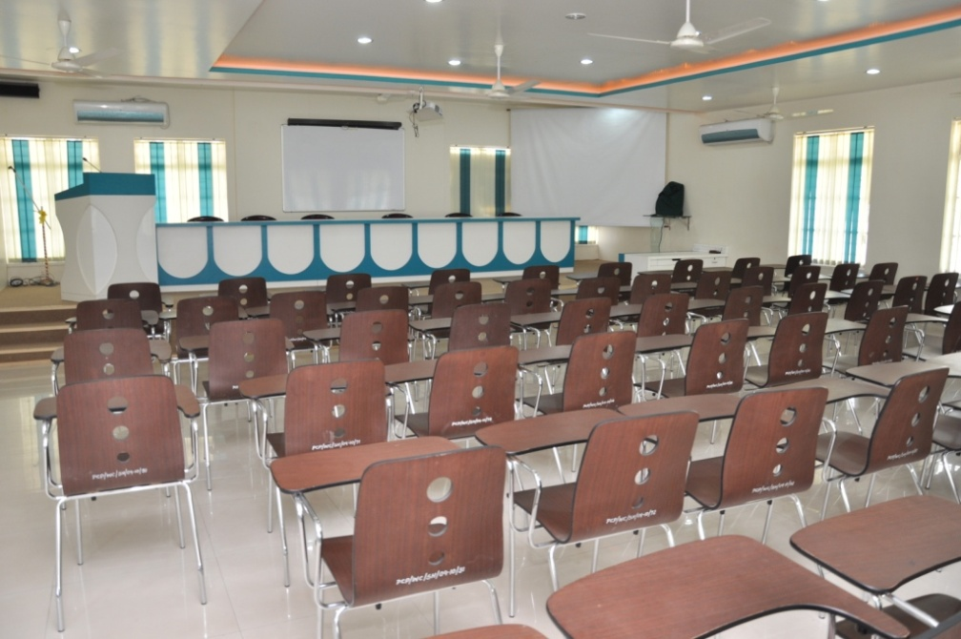

**Cafeteria / Canteen**

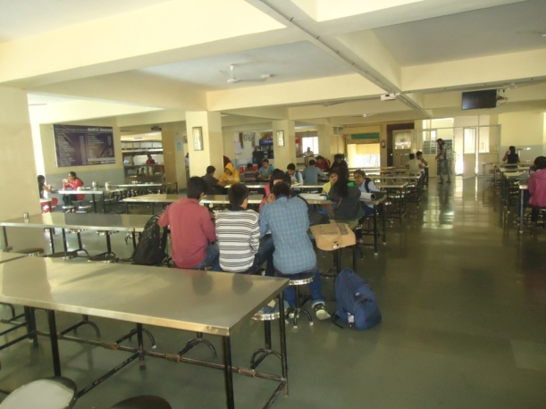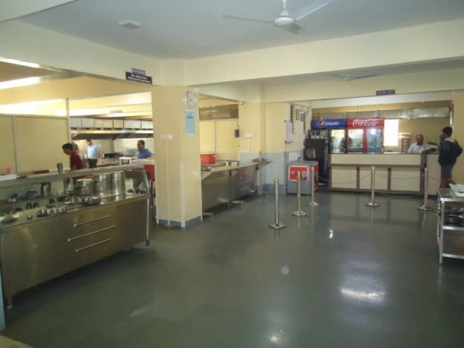

**Sport / Gym Facilities**

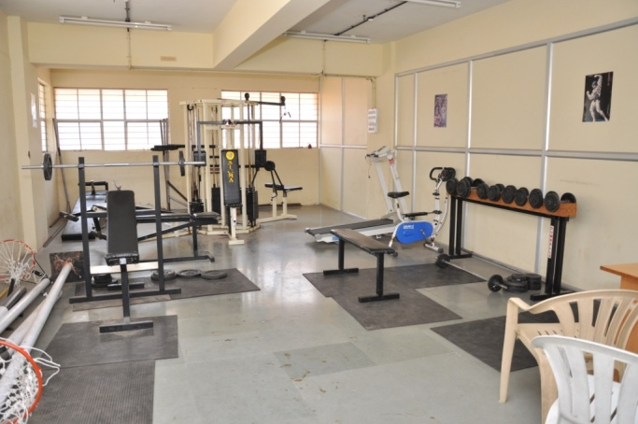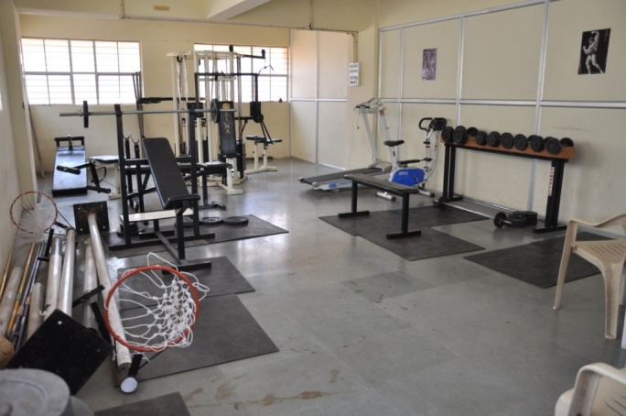

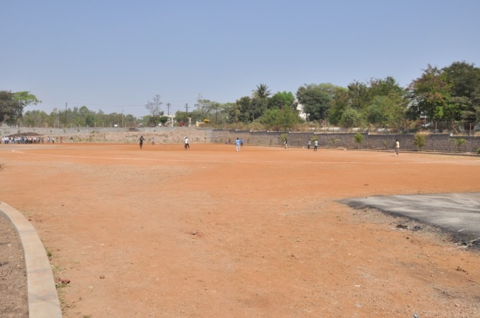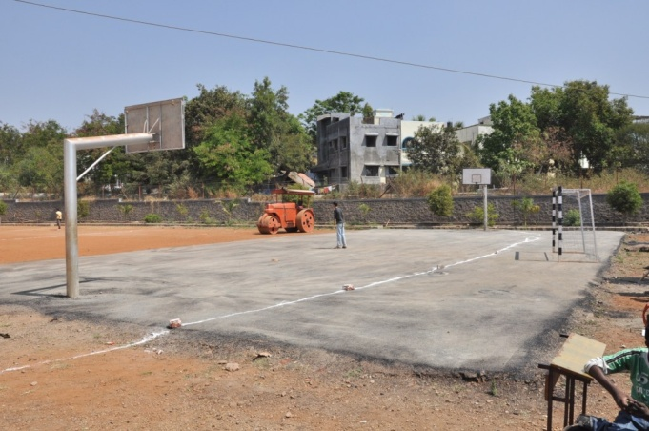

|  |  |  |
| --- | --- | --- |
| 16. | Hostel | Yes |
| 17. | Academic Sessions | As per M.S.B.T.E. Academic Calender |
| 18. | Counseling / Mentoring | Yes |
| Career Counseling | Yes |
| Medical facilities | Yes |
| Student Insurance | Yes |
| Cultural Activities | Yes |
| Sports Activities | Yes |
| Spoken Tutorial | Yes |
| Magazine / Newsletter | Yes |
| Technical activities | Yes. |
| Industrial Visits / Tours | Yes |
| Alumni activities | Yes |